**What is Python ?**

Python is an interpreted, object-oriented, high-level programming language with dynamic semantics. Its high-level built in data structures, combined with dynamic typing and dynamic binding, make it very attractive for Rapid Application Development, as well as for use as a scripting or glue language to connect existing components together. Python's simple, easy to learn syntax emphasizes readability and therefore reduces the cost of program maintenance. Python supports modules and packages, which encourages program modularity and code reuse. The Python interpreter and the extensive standard library are available in source or binary form without charge for all major platforms, and can be freely distributed.

**Why do we use Python ?**

**1) Readable and Maintainable Code**

While writing a software application, you must focus on the quality of its source code to simplify maintenance and updates. The syntax rules of Python allow you to express concepts without writing additional code. At the same time, Python, unlike other programming languages, emphasizes on code readability, and allows you to use English keywords instead of punctuations. Hence, you can use Python to build custom applications without writing additional code. The readable and clean code base will help you to maintain and update the software without putting extra time and effort.

**2) Multiple Programming Paradigms**

Like other modern programming languages, Python also supports several programming paradigm. It supports object oriented and structured programming fully. Also, its language features support various concepts in functional and aspect-oriented programming. At the same time, Python also features a dynamic type system and automatic memory management. The programming paradigms and language features help you to use Python for developing large and complex software applications.

**3) Compatible with Major Platforms and Systems**

At present, Python is supports many operating systems. You can even use Python interpreters to run the code on specific platforms and tools. Also, Python is an interpreted programming language. It allows you to you to run the same code on multiple platforms without recompilation. Hence, you are not required to recompile the code after making any alteration. You can run the modified application code without recompiling and check the impact of changes made to the code immediately. The feature makes it easier for you to make changes to the code without increasing development time.

**4) Robust Standard Library**

Its large and robust standard library makes Python score over other programming languages. The standard library allows you to choose from a wide range of modules according to your precise needs. Each module further enables you to add functionality to the Python application without writing additional code. For instance, while writing a web application in Python, you can use specific modules to implement web services, perform string operations, manage operating system interface or work with internet protocols. You can even gather information about various modules by browsing through the Python Standard Library documentation.

**5) Many Open Source Frameworks and Tools**

As an open source programming language, Python helps you to curtail software development cost significantly. You can even use several open source Python frameworks, libraries and development tools to curtail development time without increasing development cost. You even have option to choose from a wide range of open source Python frameworks and development tools according to your precise needs. For instance, you can simplify and speedup web application development by using robust Python web frameworks like Django, Flask, Pyramid, Bottle and Cherrypy. Likewise, you can accelerate desktop GUI application development using [**Python GUI frameworks**](http://www.allaboutweb.biz/python-gui-frameworks-usage/)and toolkits like PyQT, PyJs, PyGUI, Kivy, PyGTK and WxPython.

**6) Simplify Complex Software Development**

Python is a general purpose programming language. Hence, you can use the programming language for developing both desktop and web applications. Also, you can use Python for developing complex scientific and numeric applications. Python is designed with features to facilitate data analysis and visualization. You can take advantage of the data analysis features of Python to create custom big data solutions without putting extra time and effort. At the same time, the data visualization libraries and APIs provided by Python help you to visualize and present data in a more appealing and effective way. Many [**Python developers**](http://www.mindfiresolutions.com/python-development.htm) even use Python to accomplish artificial intelligence (AI) and natural language processing tasks.

**7) Adopt Test Driven Development**

You can use Python to create prototype of the software application rapidly. Also, you can build the software application directly from the prototype simply by refactoring the Python code. Python even makes it easier for you to perform coding and testing simultaneously by adopting test driven development (TDD) approach. You can easily write the required tests before writing code and use the tests to assess the application code continuously. The tests can also be used for checking if the application meets predefined requirements based on its source code.

However, Python, like other programming languages, has its own shortcomings. It lacks some of the built-in features provided by other modern programming language. Hence, you have to use Python libraries, modules, and frameworks to accelerate custom software development. Also, several studies have shown that Python is slower than several widely used programming languages including Java and C++. You have to speed up the Python application by making changes to the application code or using custom runtime. But you can always use Python to speed up software development and simplify software maintenance.

**Explain different datatypes available in Python ?**

Data type in python

Python supports three kinds of numerical data.

* **Int:** Whole number worth can be any length, like numbers 10, 2, 29, - 20, - 150, and so on. An integer can be any length you want in Python. Its worth has a place with int.
* **Float:** Float stores drifting point numbers like 1.9, 9.902, 15.2, etc. It can be accurate to within 15 decimal places.
* **Complex:** An intricate number contains an arranged pair, i.e., x + iy, where x and y signify the genuine and non-existent parts separately. The complex numbers like 2.14j, 2.0 + 2.3j, etc.

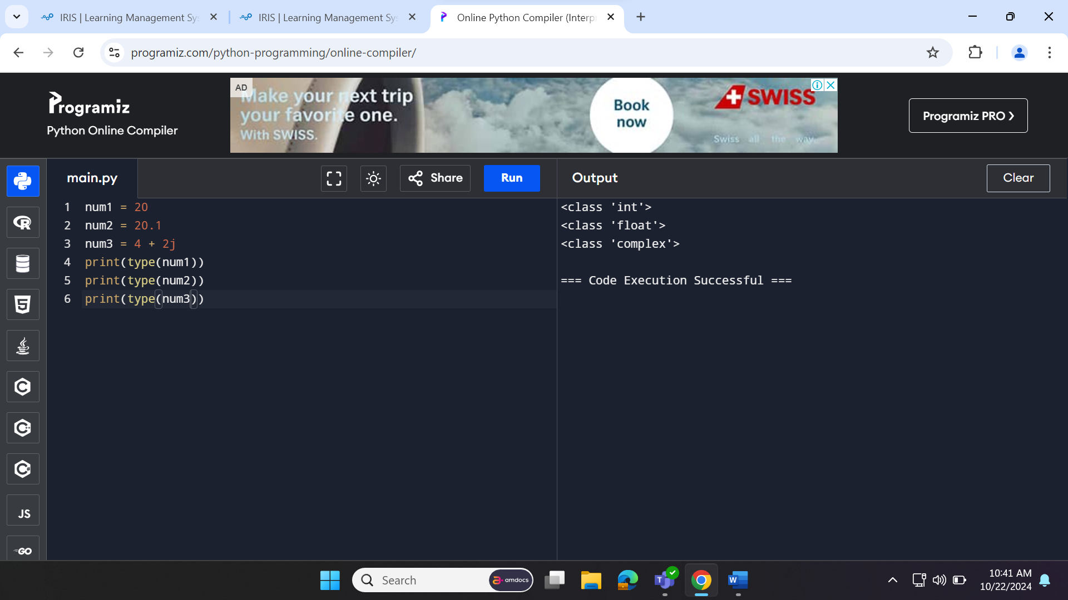

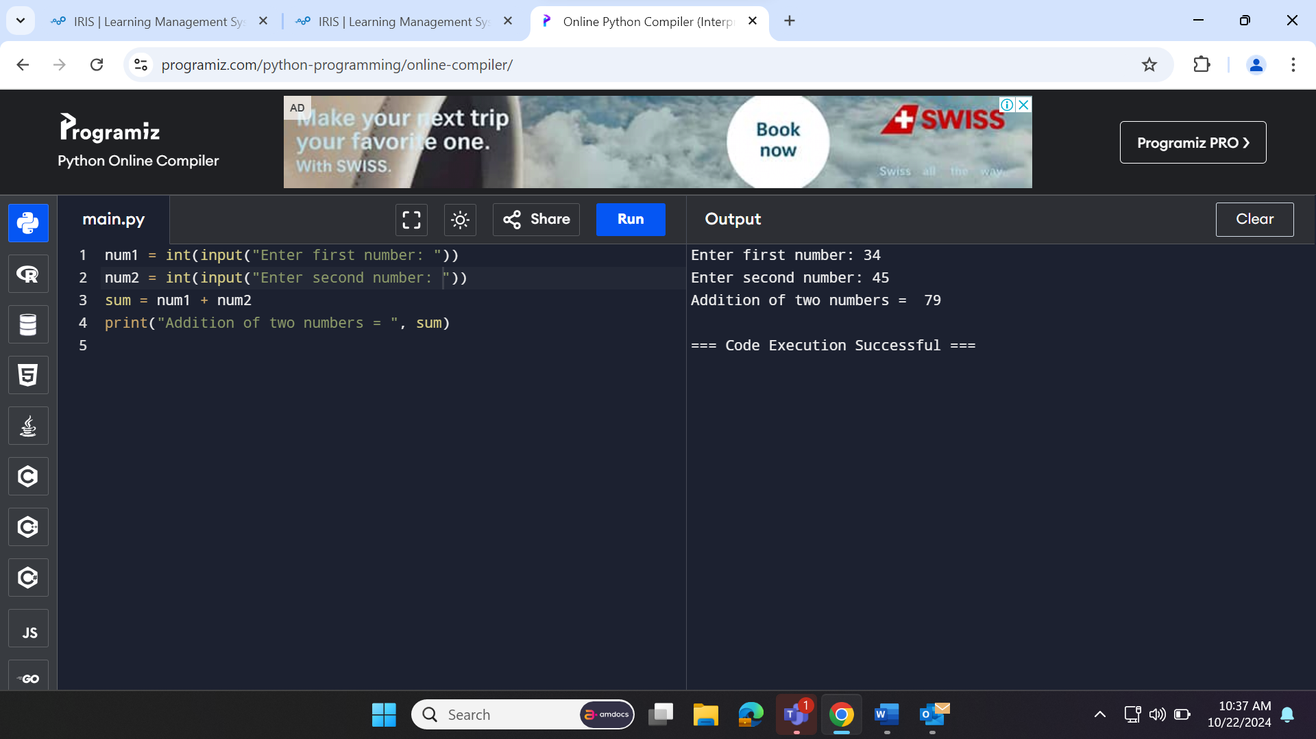

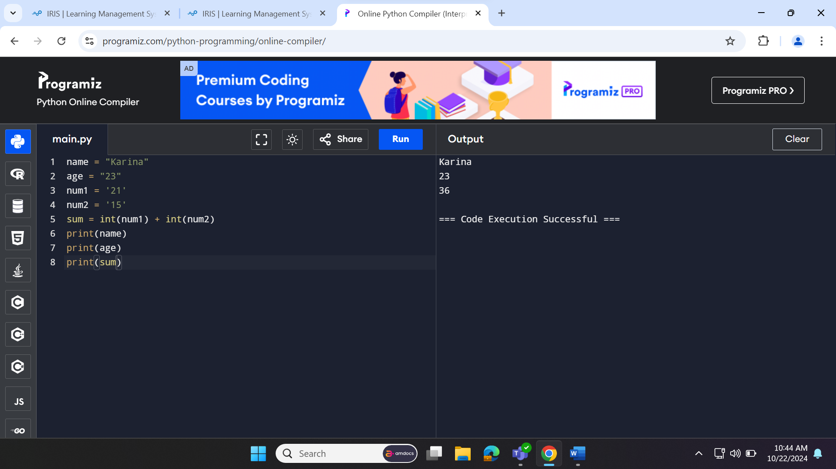

**String**

The sequence of characters in the quotation marks can be used to describe the string. A string can be defined in Python using single, double, or triple quotes.

String dealing with Python is a direct undertaking since Python gives worked-in capabilities and administrators to perform tasks in the string.

When dealing with strings, the operation "hello"+" python" returns "hello python," and the operator + is used to combine two strings.

Because the operation "Python" *2 returns "Python," the operator * is referred to as a repetition operator.

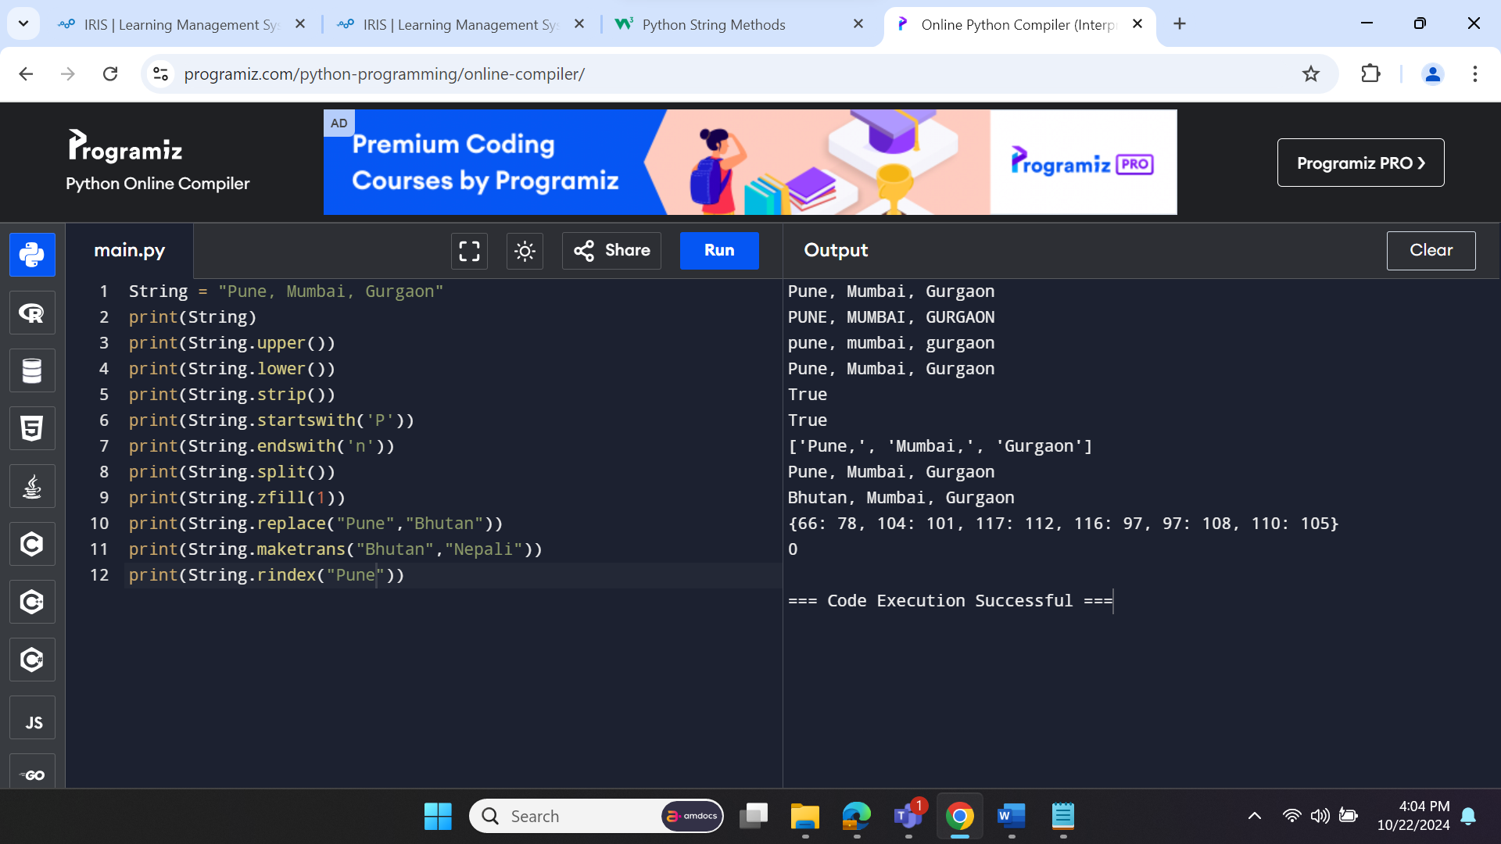

**LIST**

Lists in Python are like arrays in C, but lists can contain data of different types. The things put away in the rundown are isolated with a comma (,) and encased inside square sections [].

To gain access to the list's data, we can use slice [:] operators. Like how they worked with strings, the list is handled by the concatenation operator (+) and the repetition operator (*)

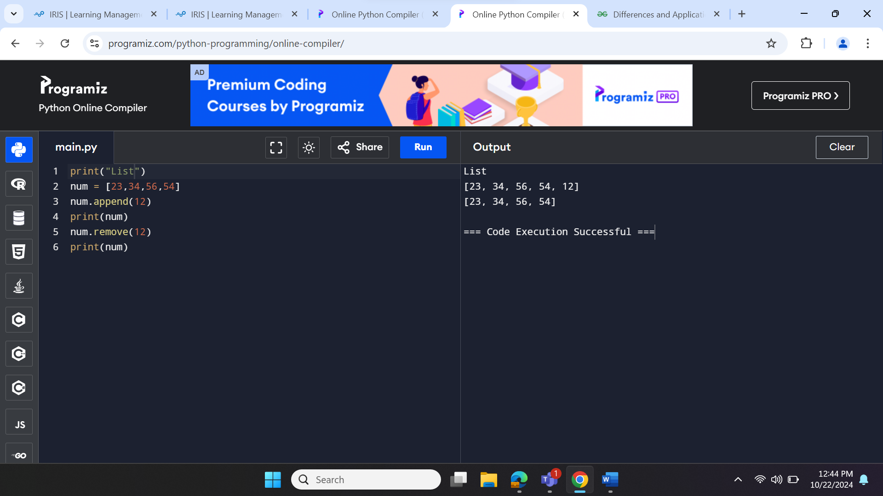

**Tuple**

In many ways, a tuple is like a list. Tuples, like lists, also contain a collection of items from various data types. A parenthetical space () separates the tuple's components from one another.

Because we cannot alter the size or value of the items in a tuple, it is a read-only data structure.

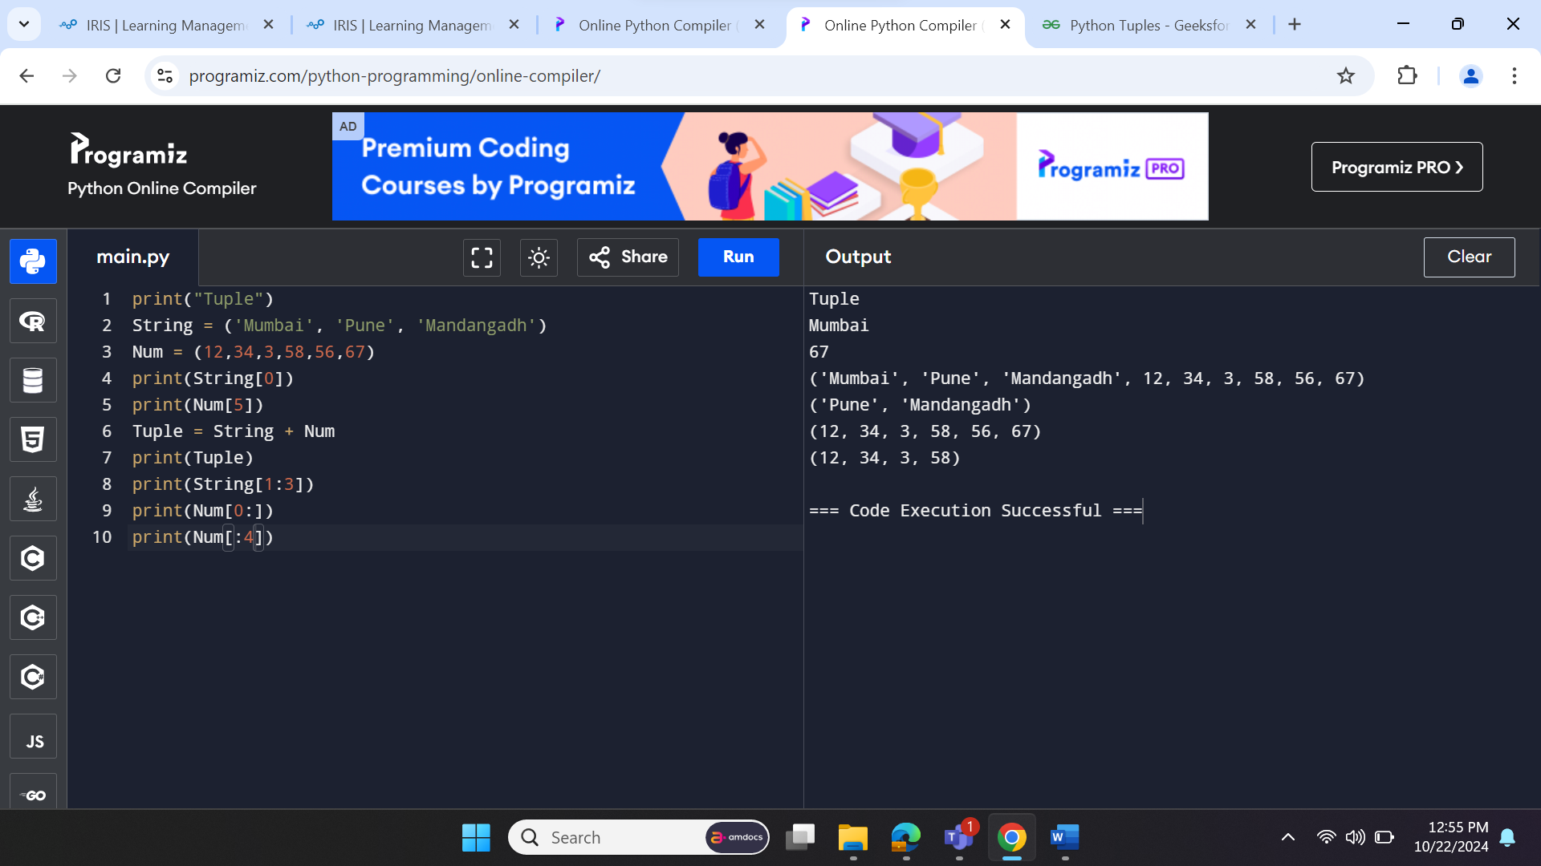

**Dictionary**

A dictionary is a key-value pair set arranged in any order. It stores a specific value for each key, like an associative array or a hash table. Value is any Python object, while the key can hold any primitive data type.

The comma (,) and the curly braces are used to separate the items in the dictionary.

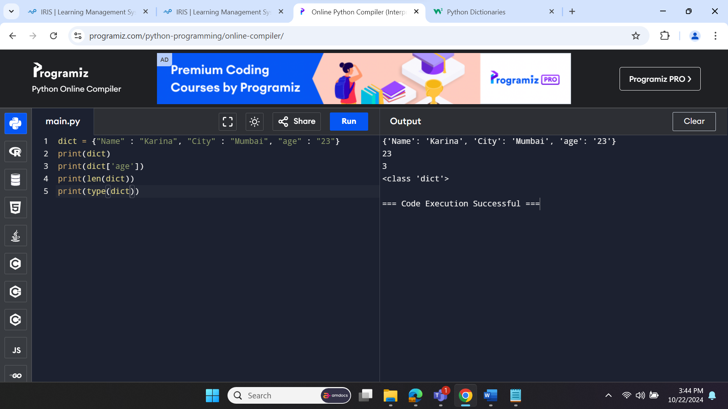

**Boolean**

True and False are the two default values for the Boolean type. These qualities are utilized to decide the given assertion valid or misleading. The class book indicates this. False can be represented by the 0 or the letter "F," while true can be represented by any value that is not zero

**Set**

The data type's unordered collection is Python Set. It is iterable, mutable(can change after creation), and has remarkable components. The elements of a set have no set order; It might return the element's altered sequence. Either a sequence of elements is passed through the curly braces and separated by a comma to create the set or the built-in function set() is used to create the set. It can contain different kinds of values.

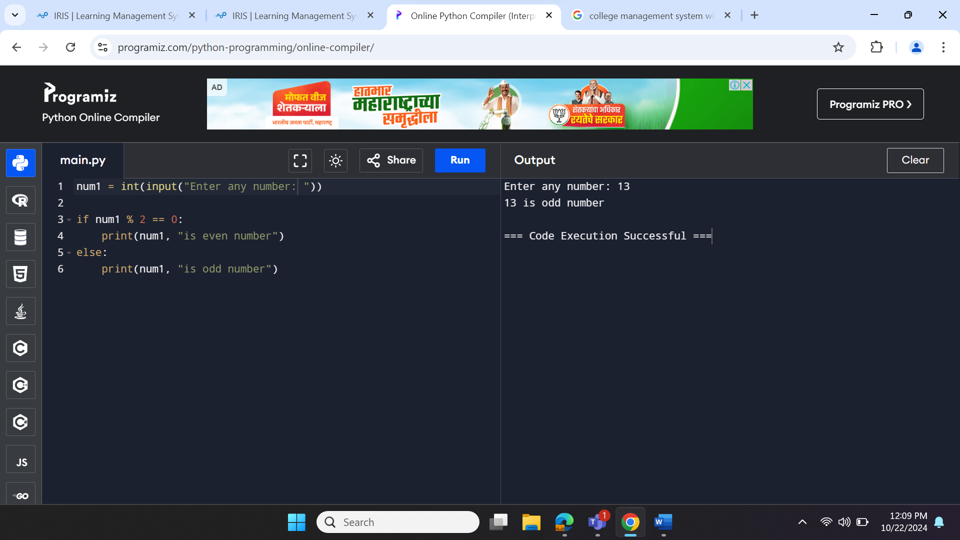

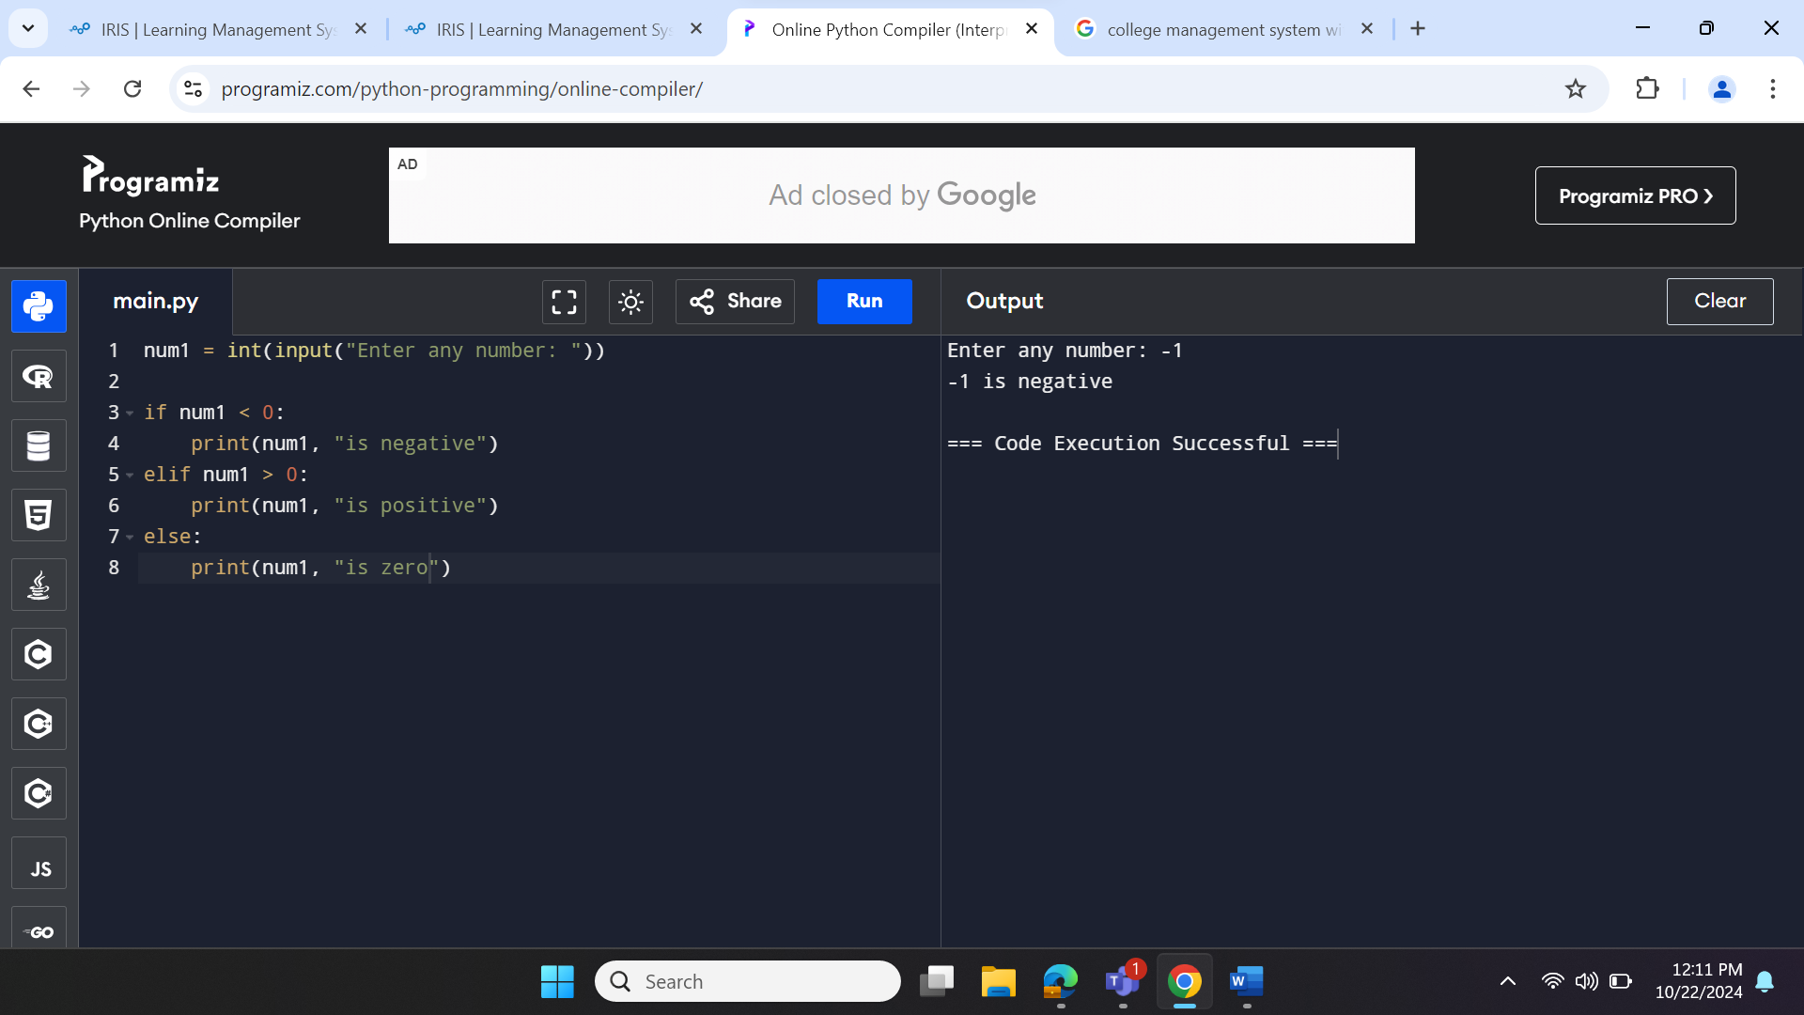

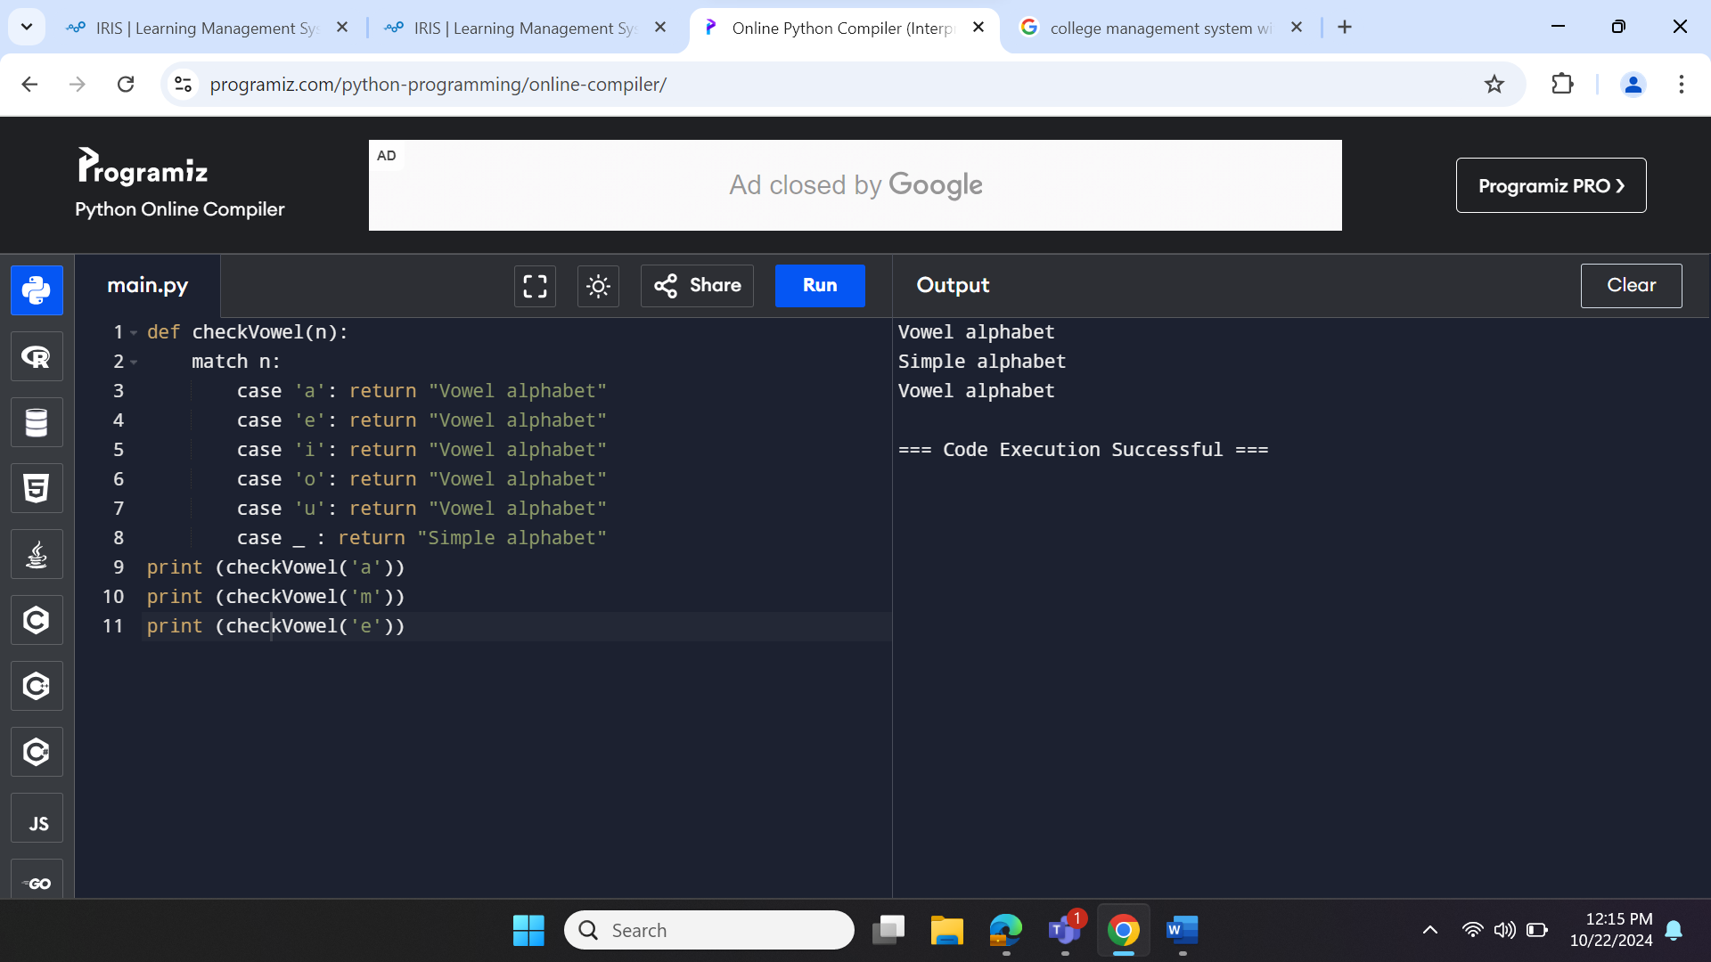

**Difference between List, Tuple, Set and Dictionary**

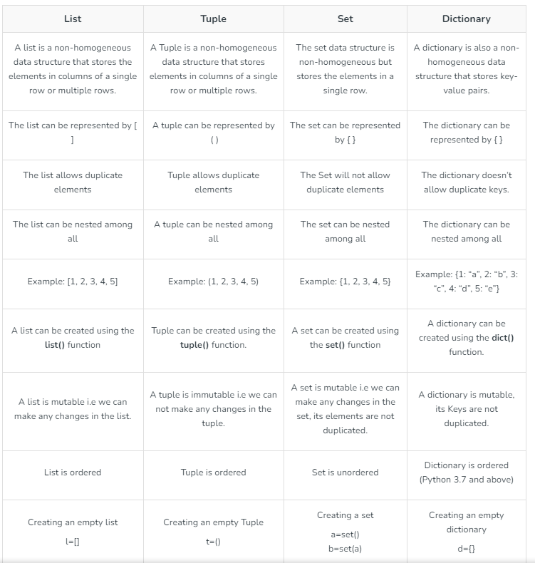

## **What is High-Level Language?**

A high-level language is a programming language that allows developers to code in a more user-friendly programming context and is mostly independent of the computer’s hardware architecture. It refers to the high level of abstraction from machine learning. High-level language deals with arrays, variables, objects, boolean expressions or arithmetic, loops and threads, locks, subroutines, functions and other abstract computer science concepts focusing on usability over optimal program efficiency.

This language allows programmers to detach and separate from the machine. Memory addressing and register usage are less of a concern than the underlying programming logic. While developing a program, a high-level language does not need to address hardware constraints. However, programmers must translate every computer program into machine language before they execute it. Examples of high-level languages are BASIC, C#, [Java](https://www.shiksha.com/online-courses/what-is-java-st619-tg17#description), etc.

## **What is Low-Level Language?**

A low-level language is a programming language with little or no abstraction from a computer’s instruction set architecture. It refers to machine code or assembly language. Because of the low abstraction between the language and the machine language, low-level languages are considered close to hardware. Because they are optimized for a certain type of system architecture, programs written in low-level languages are relatively non-portable.

There is no need for a compiler or interpreter to convert low-level languages into machine code. A small memory footprint in low-level languages allows programs to run quickly. The major focus of this language is to utilize high-level languages such as [PHP](https://www.shiksha.com/online-courses/what-is-php-st619-tg307), C#, Swift, and Assembly language. Machine language and assembly language are two examples of low-level programming. Build software programs that operate, manage, and modify a computer’s hardware and instructions set architecture.

